What is Linux?
- Multitasking platform that runs on mobile, servers and also a free and open source.
- Provides strong security and stability.
- Allows users to freely use, modify the operating system.
- Backed by a large global community.
What is Kernel?
- Kernel is the component of OS.
- It is set of predefined programs for user friendly behaviour.
- It is an open source and they can customise as per their requirements.
- It is a component that controls memory, CPU scheduling and hardware operations.
Shell and Terminal:
shell is a program which takes input and gives output. Where as terminal is a tool that execute the shell commands. Terminal is also called as “Command line Interface”.
Types of different Linux distributors
- Ubuntu
- RHEL
- Amazon Linux
- CentOS
- SUSE
Commands of Linux:
- “/ ” - Always indicates root directory.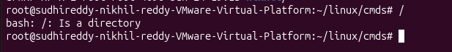
- “ ~ ” - Based on number of users Home directory will be created. 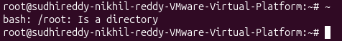
- “pwd” - Prints the full path of your current working directory. 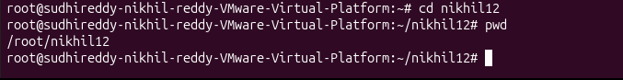
- “ls” - Lists all files and directories in the current folder. 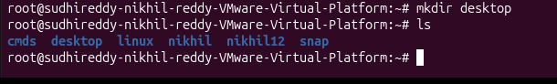
- “ll” - List of files with details. 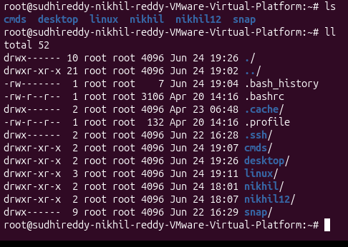
- “ll - ltr” - List of files with details. 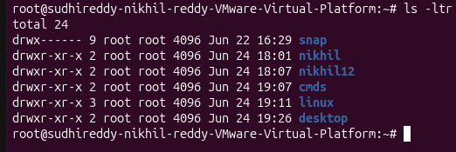
- “cd” - Changes the active directory to a specified path. 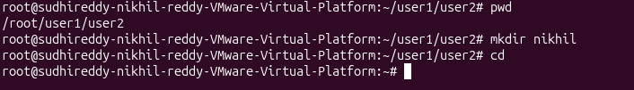
- “cd ..” - moves one step back. 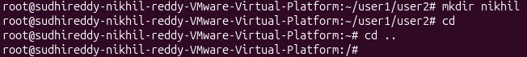
- “cd ../..” - moves two steps back. 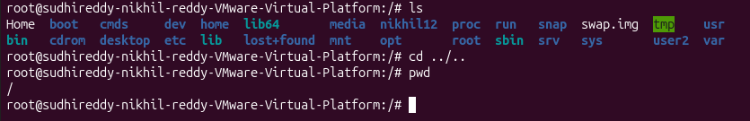
- “ls -a” - Shows the hidden files. 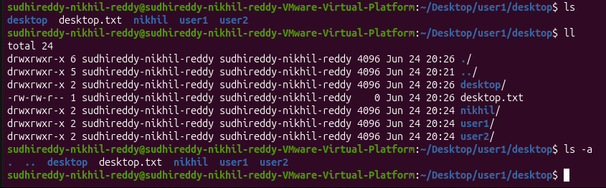
- “Mkdir”- Creates a new empty directory. 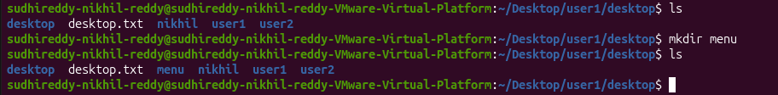
- “touch” - Creates a blank text file.
- “cp” - Copies files or folders to a specified destination. 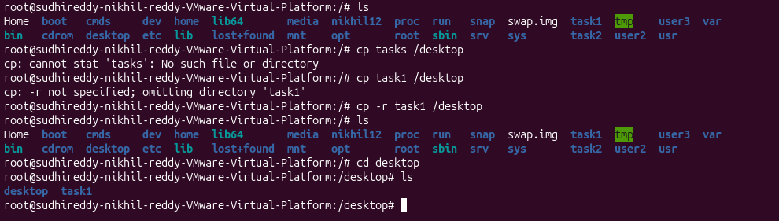
- “mv”- Moves or renames files and folders. 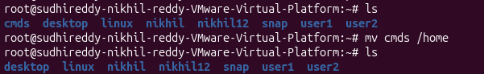
- “rm” - Permanently deletes files. Use rm -r for directories. 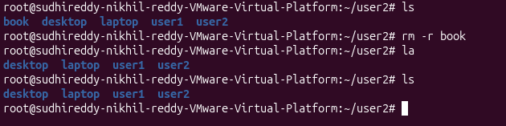
- “Date” - Gives the date. 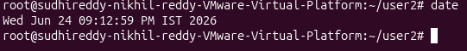
- “clear” - It will clear the commands. Before clear command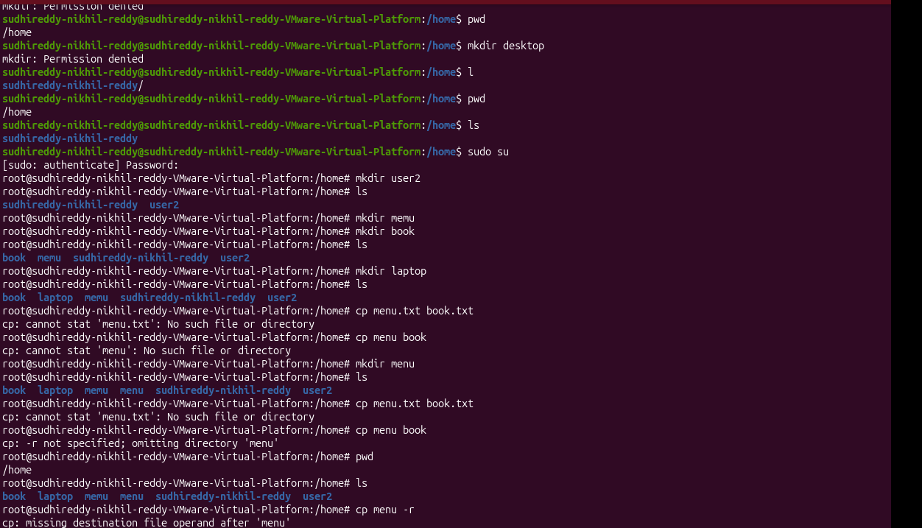after clear command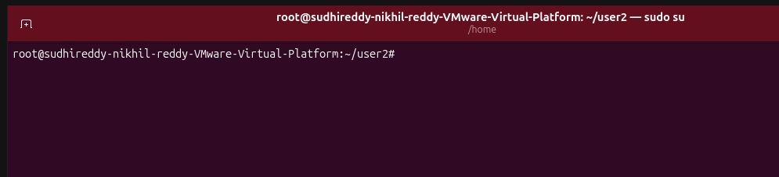

Editors in linux:
- VI
- VIM
- NANO

Vi editor in linux
The default editor that comes with the Linux/UNIX operating system is called vi
Vi filename command – it opens the editor of the linux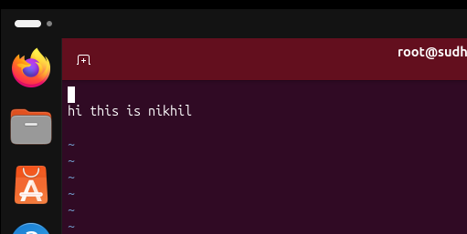

- “cat” - To read the content of the file.
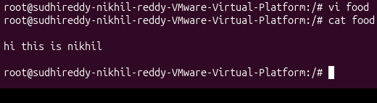
- “:wq!” – to come out the editor
